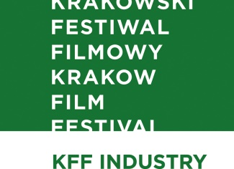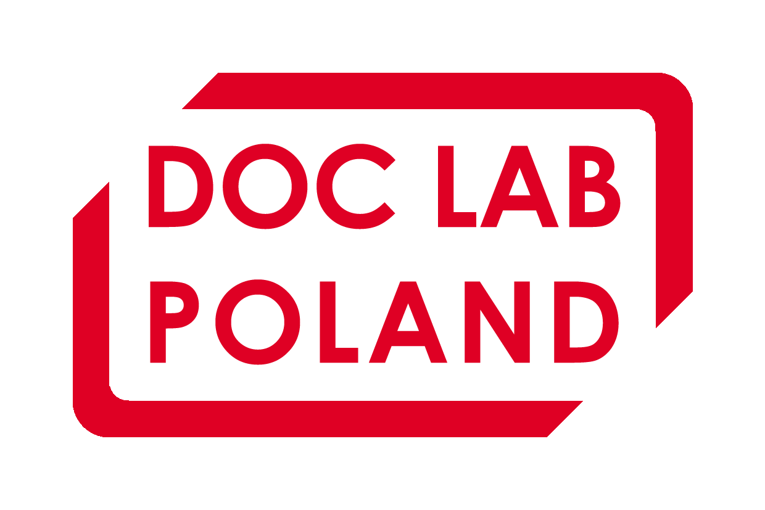

KFF INDUSTRY AND DOC LAB POLAND AWARDS

ANIMATED IN POLAND
Audiovisual Technology Center Special Mention - project of the film LOVE, dir. Michał and Jakub Socha, prod. Jakub Karwowski, Piotr Szczepanowicz /Letko
Sound Mind Award - project of the film LOVE IN THE TIME OF COAL-BASED ECONOMY, dir. Tomasz Siwiński, prod.Jakub Karwowski, Piotr Szczepanowicz /Letko

DOCS TO START

Władysław Ślesicki Film Foundation Special Mentions:
project of the film MISS OF POLAND, dir. Jana Shostak, Jakub Jasiukiewicz, prod. Katarzyna Drapała /WFDiF
project of the film MY BIG BIBA, dir. Judyta Fibiger, prod. Robert Rhodin/ White Shark Studios
project of the film BROTHERHOOD, dir. Hanna Maciąg, prod. Maria Wachowiak, Anna Waligórska / No Prob Production House
DOK Leipzig Special Mention - project of the film TOGETHER, dir. Marek Kozakiewicz, prod. Agnieszka Skalska / Koi Studio
Uchostudio Award - project of the film WHEN THE WIND BECOMES SILENT, reż. Mateusz Gołębiewski, prod. Małgorzata Domin, Dominika Mandla, Kinga Mielnik / Domino Film
ColorOffOn Award - project of the film I WANT IT ALL, dir. Katarzyna Wiśniowska, prod. Tomasz Morawski / Haka Films
HBO Award - project of the film LILI, dir. Sylwia Rosak, produkcja: Tomasz Morawski / Haka Films

DOCS TO GO!

Institute of Documentary Film Special Mention - project of the film THE PAWNSHOP, dir. Łukasz Kowalski, prod. Łukasz Kowalski, Anna Mazerant / 4.30 Studio
ColorOffOn Award - project of the film NO HERO AT ALL, dir. Michał Kawecki, prod. Maria Siniarska / Unlimited Film Operations

