SAVE THE DATE

Film Festival Spring: One Journey to 3 Festivals

Between May 28th and June 7th, professionals from the short film industry will have the opportunity to combine the pleasant with the useful and to enjoy three spring events in one festival trip. Vienna Shorts (AT), Krakow Film Festival (PL) and the Kurzfilm Festival Hamburg (DE) have coordinated their industry activities so that a visit to all three festivals is not only easily feasible but will also be more than worthwhile:

Industry Days:
Vienna Shorts (May 29–31), Krakow FF (June 1–3 ), Hamburg (June 4–6 )
Food for thoughts & drinks for fun – with filmmakers, programmers & industry experts

The three festivals can be combined by train for a total of around 70 euros (Vienna–Krakow–Hamburg route, if booked in advance). The first 10 professionals who wish to take advantage of the triple package will receive free accreditation, a surprise special from each festival & the Industry Gold Card Treat at the festival bar in Hamburg.

Accreditations for the three festivals are available from mid/end of March. If you are interested in the package, please contact the guest department of one of the three festivals under: guest@ … viennashorts.com, kff.com.pl or shortfilm.com

Vienna Shorts, May 28 – June 2, www.viennashorts.com
Krakow Film Festival, May 31 – June 7, www.krakowfilmfestival.pl
Kurzfilm Festival Hamburg, June 2 – 8, www.shortfilm.com

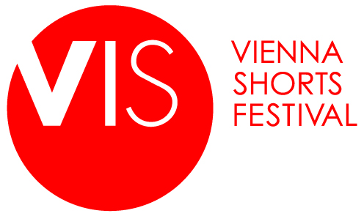 |  | 

