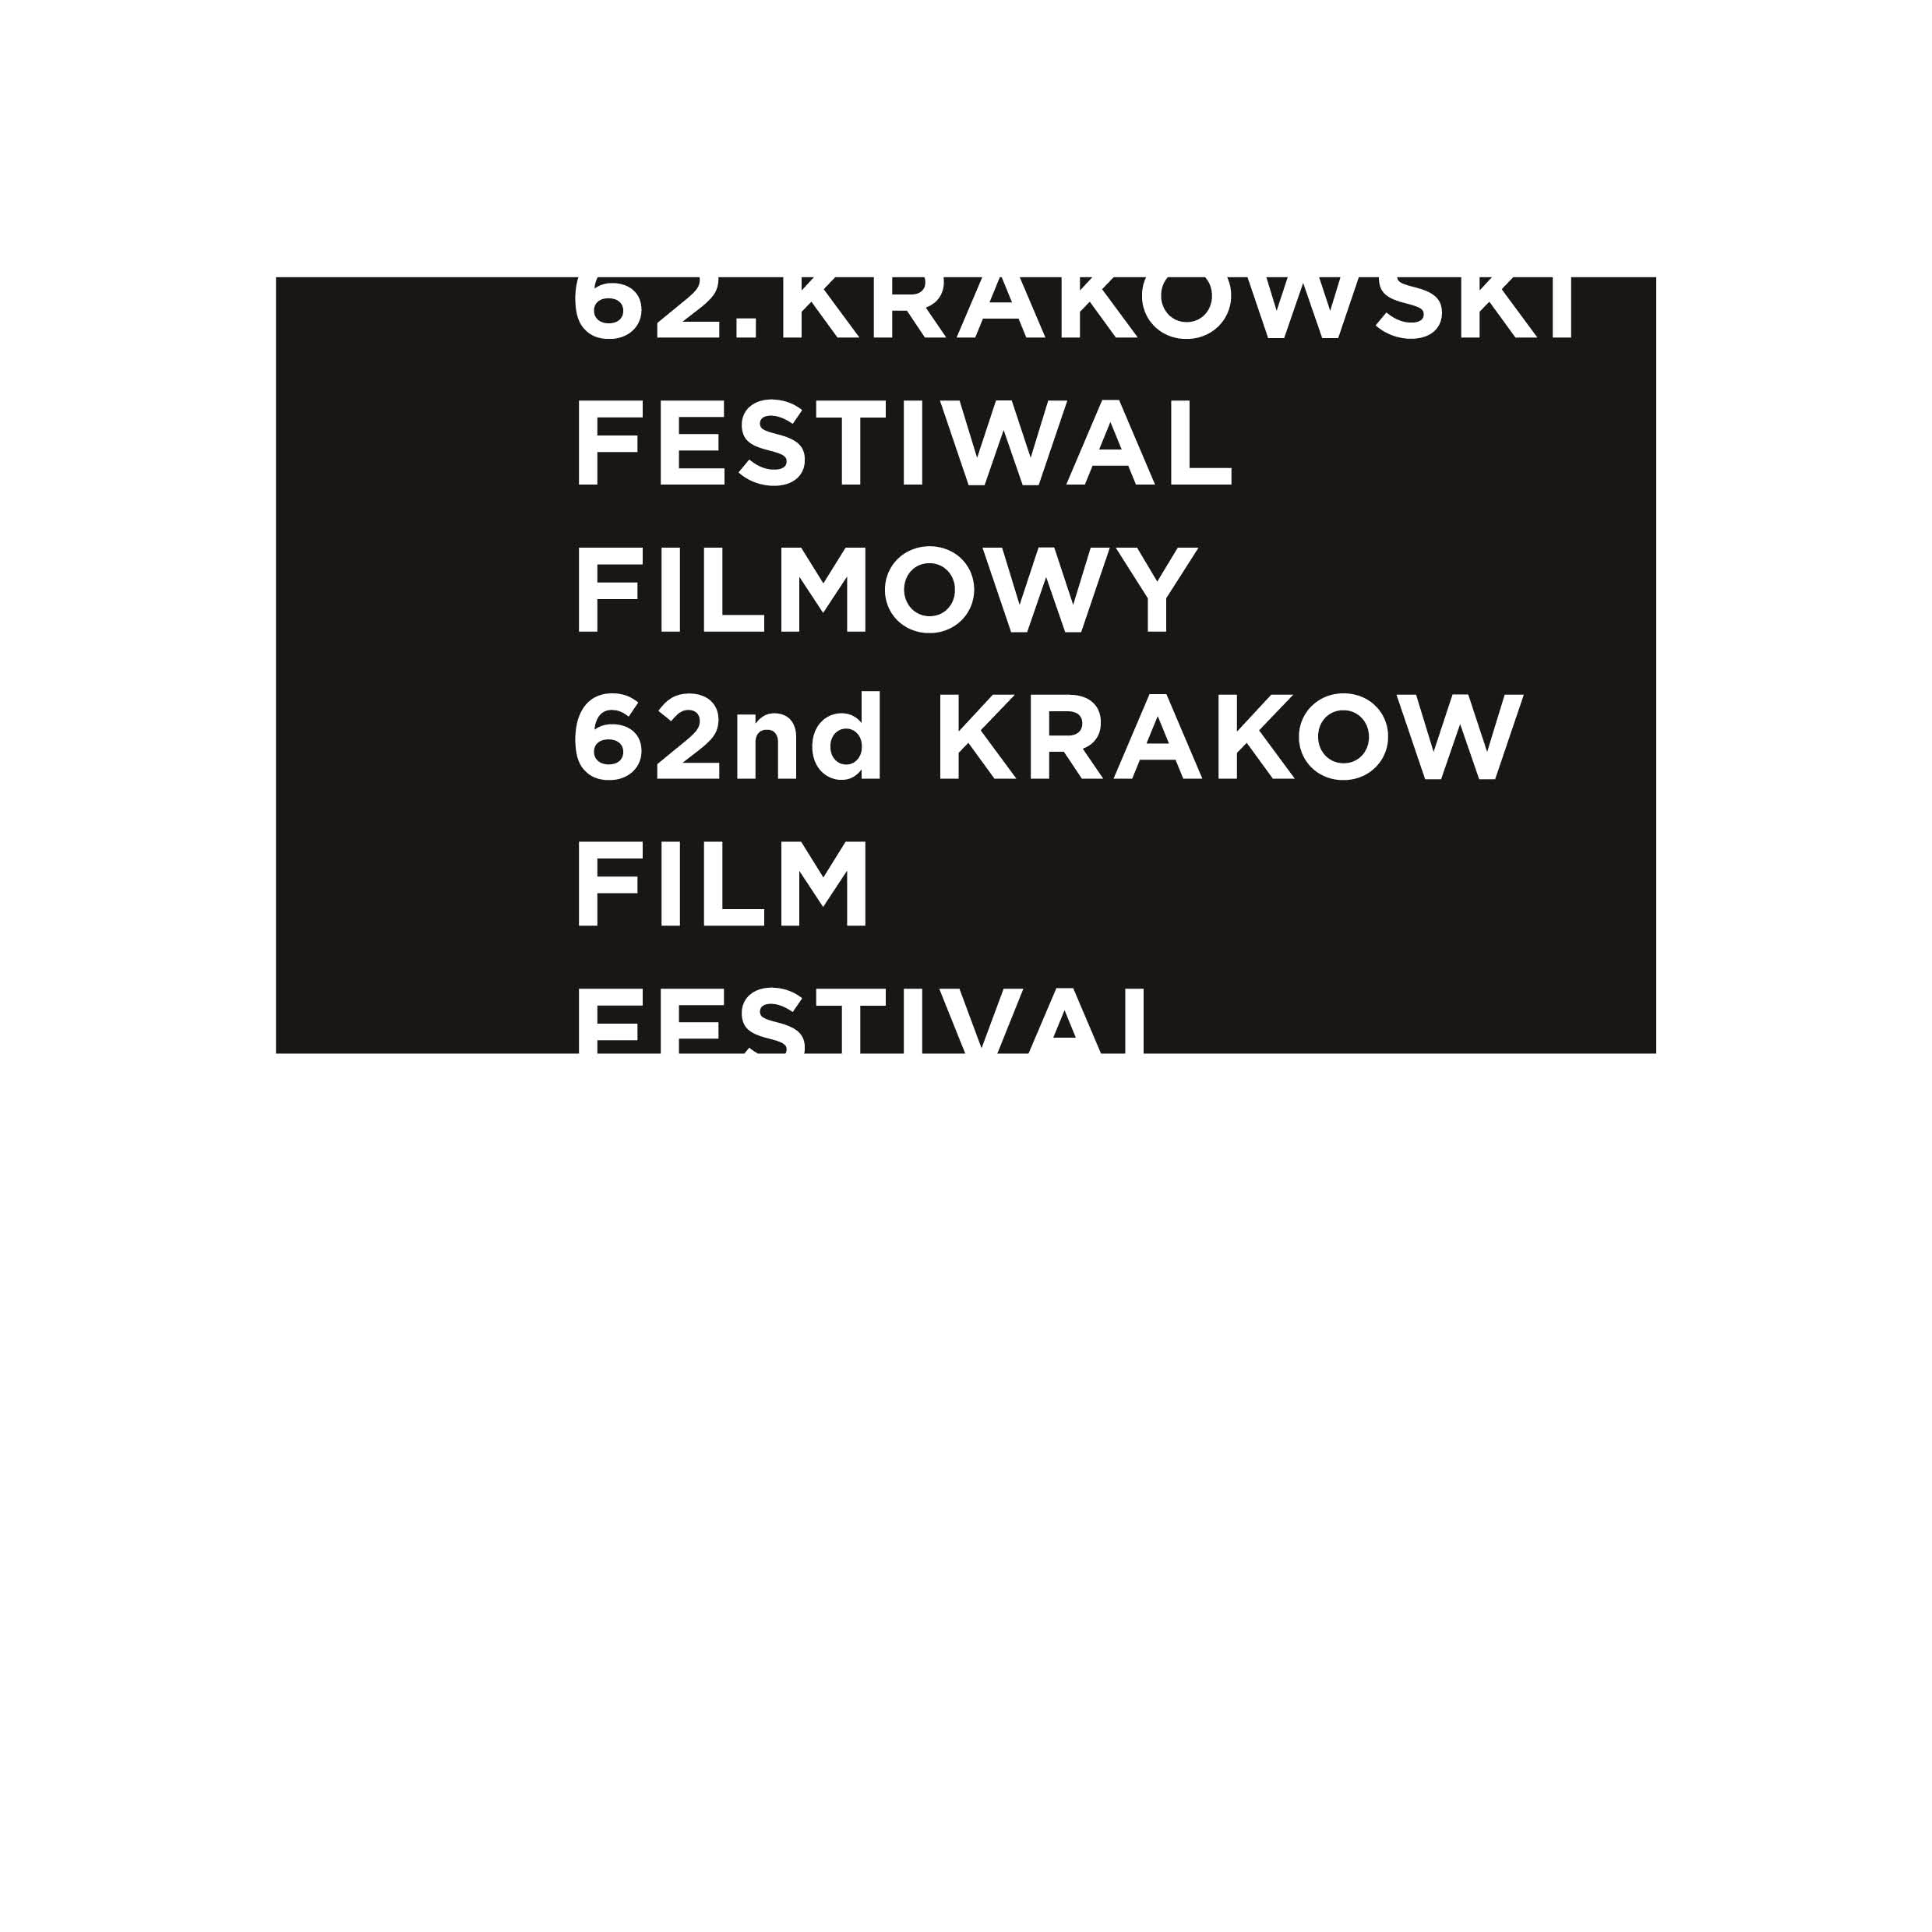

AWARDS of the 62st Krakow Film Festival

DRAGON OF DRAGONS AWARD for the contribution into development of the world animated film
JARMO JÄÄSKELÄINEN (Finland)

KFF RECOMMENDATION to the European Film Award in a documentary category

BOYLESQUE, dir. Bogna Kowalczyk (Poland)

INTERNATIONAL DOCUMENTARY COMPETITION

Having watched all the competitive films the International Documentary Jury of the 62st Krakow Film Festival consisting of: Till Brockmann – chairman (Switzerland), Christine Camdessus (France), Ohad Milstein (Israel), Petrula Veljanovska (North Macedonia), Agnieszka Zwiefka (Poland) has decided to award the following prizes:

THE GOLDEN HORN for the director of the best film – Denis Dobrovoda for The Cathedral (Slovakia)

THE SILVER HORN for the director of the film with high artistic values – Shaunak Sen for All That Breathes (USA, United Kingdom, India)

THE SILVER HORN for the director of the film on social issues – Laura Sistero for Tolyatti Adrift (Spain)

SPECIAL MENTION for The Hamlet Syndrome directed by Elwira Niewiera and Piotr Rosołowski (Poland, Germany)

SPECIAL MENTION for Fragile Memory directed by Igor Ivanko (Ukraine, Slovakia)

The FIPRESCI (International Federation of Film Critics) Jury consisting of: Nino Kovačić (Croatia), Yun-Hua Chen (Taiwan), Giuseppe Sedia (Italy) has decided to award the International Film Critics Prize to Hirotoshi Takeoka for Adamiani (Japan, The Netherlands)

INTERNATIONAL SHORT FILM COMPETITION

Having watched all the competition films, the International Short Film Jury consisting of: Juliusz Machulski – chairman (Poland), Olga Lucovnicova (Moldova), Andrea Martignoni (Italy), Anita Reher (Denmark) and Amer Salmeen Al Murry (United Arab Emirates), has decided to award the following prizes:

GOLDEN DRAGON for the director of the best film – Jay Rosenblatt for How Do You Measure A Year? (USA)

SILVER DRAGON for the director of the best documentary film – Raúl de la Fuente Calle and Amaia Ramirez for Maldita. A Love Song to Sarajevo (Spain)

SPECIAL MENTION for Hardcore directed by Adán Aliaga (Spain)
SILVER DRAGON for the director of the best animated film – Diana Cam Van Nguyen for Love, Dad (Czech Republic, Slovakia)
SPECIAL MENTION for A Goat’s Spell directed by Gerhard Funk (Germany)
SILVER DRAGON for the director of the best short fiction film – Karolina Porcari for Victoria (Poland)

SPECIAL MENTION for The Swarmers directed by Alison Kuhn (Germany)

Jury Award for the Best European Film (Krakow Candidate to the European Film Award 2022 in the short film category) – Diana Cam Van Nguyen for Love, Dad (Czech Republic, Slovakia)

The International Federation of Film Societies (FICC) Jury consisting of: Eugene Dugan-Brause (United Kingdom), Ritesh Basak (Indie), Karolina Nowacka (Polska) has decided to grant the Don Quixote Award to the film Parizad directed by Mehdi Imani Shahmiri (Iran) and the Special Mention to the film: Love, Dad directed by Diana Cam Van Nguyen (Czech Republic, Slovakia)

INTERNATIONAL DOCFILMMUSIC COMPETITION

Having watched all the competition films, the International DocFilmMusic Competition Jury consisting of: Włodek Pawlik – chairman (Polska), Roman Gutek (Polska) and Robert Kirchhoff (Slovakia) has decided to award the following prizes:

GOLDEN HEYNAL for the director of the best film - Lucie Králová for Kapr Code (Czech Republic, Slovakia)

SPECIAL MENTION for Cesária Évora directed by Ana Sofia Fonseca (Portugal)

NATIONAL COMPETITION

Having watched all the competition films, the National Competition Jury consisting of: Piotr Stasik – chairman, Daria Kopiec, Kuba Mikurda, Anna Sienkiewicz-Rogowska, Małgorzata Szyła has decided to award the following prizes:

GOLDEN HOBBY-HORSE for the director of the best film funded by the President of the Polish Filmmakers Association – Elwira Niewiera and Piotr Rosołowski for The Hamlet Syndrome (Poland, Germany)
SILVER HOBBY-HORSE for the director of the best documentary film over 30 minutes – Bogna Kowalczyk for Boylesque (Poland)

SILVER HOBBY-HORSE for the director of the best documentary film under 30 minutes – Marcin Lesisz for The Rocking Horses (Poland)

SILVER HOBBY-HORSE for the director of the best animated film – Marta Pajek for Impossible Figures and Other Stories I (Poland, Canada)

SILVER HOBBY-HORSE for the director of the best short fiction film – Michał Toczek for A Dead Marriage (Poland)

The Award of the President of the Polish Filmmakers Association for the best film editing – Milenia Fiedler for The Voice (Poland)

Maciej Szumowski Award for remarkable social awareness patronized by Medicine – Bartłomiej Żmuda for God and Lunaparks' Warriors (Poland)

The Award for the best short and documentary films producer in Poland funded by the Polish Producers Alliance (KIPA) and FDR Studio – Magdalena Kamińska and Agata Szymańska (Balapolis) for the film The Hamlet Syndrome (Poland, Germany)

Best Cinematography Award under the patronage of The Polish Society of Cinematographers funded by Black Photon – Wojciech Staroń for the film The Voice (Poland)

THE AUDIENCE AWARD

Boylesque directed by Bogna Kowalczyk
(Poland)

THE AWARD OF THE STUDENT JURY
Having watched all the competitive films, the Student Jury consisting of Monika Babińska, Aleksandra Brzuzy, Katarzyna Burdek, Paulina Gandor, Arkadiusz Hulbój, Przemysław Kania, Weronika Kapusta, Jędrzej Kościński, Mateusz Leśniak, Krzysztof Strumiński has decided to award film The Hamlet Syndrome (Poland, Germany) directed by Elwira Niewiera and Piotr Rosołowski

KFF INDUSTRY - ANIMATED IN POLAND I DOC LAB POLAND AWARDS 2022

ANIMATED IN POLAND AWARDS

SOUND MIND STUDIO AWARD – a coupon for 10 days of sound postproduction in Sound Mind studio run by Michał Fojcik for the project Magda, dir. Adela Kaczmarek - Siwińska, prod. Letko

FIXAFILM AWARD – a coupon for image post-production services worth PLN 10 000 founded by Fixafilm for the project The Miracle, dir. Ewa Borysewicz, prod. Letko

CREW UNITED SPECIAL MENTION – a 5-years’ Premium membership to Crew United platform for the director and producer of the awarded project for the project Conjunction, dir. Marta Magnuska, prod. Animoon

DOC LAB POLAND AWARDS

AWARDS FOR THE BEST PROJECTS PRESENTED AT DOCS TO START

HBO Max Award– 10 000 PLN in cash for the project Insurance Against Meteorites, dir. and prod. Natalia Śliwowska and Jorik Amit Galama

ORKA Award – image postproduction services worth of 20 000 PLN for the project The Perfect Date, dir. Małgorzata Goliszewska, prod. Agnieszka Skalska / ZPR MEDIA / KOI STUDIO

FIXAFILM Award – image postproduction services worth of 15 000 PLN for the project Tenderness of Transience, dir Mateusz Mularski, prod. Joanna Zielińska / BIG WAVE FILMS

MX35 Award – film equipment rental services worth of 10 000 PLN for the project A Hole in the Wall, dir. Arjun Talwar, prod. Karolina Śmigiel / UNI-SOLO STUDIO
DOK Leipzig Special Mention – invitation to Co‐pro Meetings in Leipzig for the project A Hole in the Wall, dir. Arjun Talwar, prod. Karolina Śmigiel / UNI-SOLO STUDIO
Institute of Documentary Film Special Mention – invitation to East Doc Platform for the project Towards the Sun, dir. Agnieszka Kokowska, prod. Justyna Ziemkiewicz, Sławomir Richert / WARSAW PRODUCTION TEAM

Polish Docs Pro Special Mention – support of international promotion and invitation to one of the key world documentary industry event for the project GO&SEE, dir. Julia Kuzka, prod. Małgorzata Małysa / FURIA FILM

AWARDS FOR THE BEST PROJECTS PRESENTED AT DOCS TO GO

SMAKJAM Award – image postproduction services worth of 25 000 PLN for the project The Coal Daughter, dir. Aneta Nowicka, prod. Jacek Kucharski / TRAFIK

ORKA Award – image postproduction services worth of 20 000 PLN for the project Sings of Mr. Plum, dir. Urszula Morga, Bartosz Mikołajczyk, prod. Stanisław Zaborowski, Jan Borowiec / SILVER FRAME

ORKA Award – image postproduction services worth of 20 000 PLN for the project Fear Out Of Head, dir. Grzegorz Brzozowski, prod. Natalia Grzegorzek / KOSKINO

CAFE OLE Award – sound postproduction services worth of 10 000 PLN for the project Hasan’s Joy, dir. Natalia Pietsch, Grzegorz Piekarski prod Katarzyna Kostecka / LARMO

Institute of Documentary Film Special Mention – invitation to East Doc Platform for the Hasan’s Joy, dir. Natalia Pietsch, Grzegorz Piekarski prod Katarzyna Kostecka / LARMO

The Władysław Ślesicki Film Foundation Special Mention – invitation Co‐pro Meetings in Leipzig for the project Faces of Agata, dir. Małgorzata Kozera, prod. Maria Krauss / PLESNAR & KRAUSS FILMS

