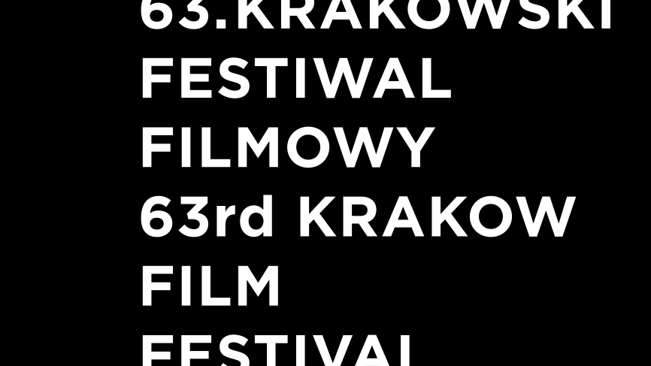

AWARDS of the 63st Krakow Film Festival

DRAGON OF DRAGONS AWARD for the contribution into development of the world animated film
MICHAEL DUDOK DE WIT (Netherlands)

KFF RECOMMENDATION to the European Film Award in a documentary category

SONGS OF EARTH, dir. Margreth Olin (Norway)

INTERNATIONAL DOCUMENTARY COMPETITION

Having watched all the competitive films the International Documentary Jury of the 63rd Krakow Film Festival consisting of: Andrzej Fidyk – chairman (Poland), Karen Avetisyan (Armenia), Mette Hoffmann Meyer (Denmark), Ada Solomon (Romania) has decided to award the following prizes:

THE GOLDEN HORN for the directors of the best film – Nick Read and Ayse Toprak for My Name is Happy (United Kingdom, Turkey)

THE SILVER HORN for the director of the film with high artistic merit – Tunde Skovran for Who I Am Not (Romania, Canada)

THE SILVER HORN for the director of the film on social issues – Ella Glendining for Is There Anybody Out There? (United Kingdom)

The FIPRESCI (International Federation of Film Critics) Jury consisting of: Igor Angjelkov (Macedonia), Antonios Lagarias (France), Paweł Mossakowski (Poland) has decided to award the International Film Critics Prize to Ella Glendining for Is There Anybody Out There (United Kingdom)

INTERNATIONAL SHORT FILM COMPETITION

Having watched all the competition films, the International Short Film Jury consisting of: Jan Naszewski – chairman (Poland), Isabelle Favez (Switzerland), Anne Gaschütz (Germany) and Brigid O’Shea (Australia/Germany) has decided to award the following prizes:

GOLDEN DRAGON for the directors of the best film – Tomek Popakul and Kasumi Ozeki for Zima (Poland)

SILVER DRAGON for the director of the best documentary film – Yaser Talebi for Daughter (Iran)
SILVER DRAGON for the director of the best animated film – Sofiia Melnyk for MAriupol. A Hundred Nights (Ukraine, Germany)
SILVER DRAGON for the director of the best short fiction film – David Arslanian for Underdog (France)

Jury Award for the Best European Film (Krakow Candidate to the European Film Award 2023 in the short film category) – Szymon Ruczyński for There Are People in the Forest (Poland)

The International Federation of Film Societies (FICC) Jury consisting of: Maria Eriksson (Sweden), Anita Petra Hamremoen (Norway), Grzegorz Pieńkowski (Polska) has decided to grant the Don Quixote Award to the film Underdog directed by David Arslanian (France) and the Special Mention to the film: Mariupol. A Hundred Nights directed by Sofia Melnyk (Ukraine, Germany)

INTERNATIONAL DOCFILMMUSIC COMPETITION

Having watched all the competition films, the International DocFilmMusic Competition Jury consisting of: Włodek Pawlik – chairman (Polska), Roman Gutek (Polska) and Robert Kirchhoff (Slovakia) has decided to award the following prizes:

GOLDEN HEYNAL for the director of the best film - Agnieszka Iwańska for Ula (Poland)

SPECIAL MENTION for La Singla directed by Paloma Zapata (Spain)

NATIONAL COMPETITION

Having watched all the competition films, the National Competition Jury - Short Films consisting of: Jagoda Szelc – chairwoman, Damian Kocur and Joanna Wendorff-Ostergaart has decided to award the following prizes:

GOLDEN HOBBY-HORSE for the director of the best fiction film – Michał Toczek for Be somebody (Poland)
GOLDEN HOBBY-HORSE for the director of the best documentary film – Mateusz Pietrak for Basia: Three Short Stories (Poland)
GOLDEN HOBBY-HORSE for the director of the best animated film – Tomek Popakul, Kasumi Ozeki for Zima (Poland)
SPECIAL MENTION for the directors - Jakub Stroszek, Magdalena Mistygacz for Iriy (Poland, Ukraine)

Award of the Centre for Audiovisual Technologies CeTA in Wrocław for the first or second short feature film with a value of PLN 50 000 in the form of an in-kind contribution to the production or post-production of the next project for Bartek Stankiewicz for - Polar Bears

Having watched all the competition films, the National Competition Jury - Documentary Films consisting of: Maciej Cuske – chairman, Maciej Kubicki and Ita Zbroniec-Zajt has decided to award the following prizes:

GOLDEN HOBBY-HORSE for the director of the best documentary film above 30 minutes – Małgorzata Kozera for Faces of Agata (Poland)
SPECIAL MENTION for the director - Paweł Hejbudzki for Wiraż (Poland)
SPECIAL MENTION for the director - Clara Kleininger-Wanik for No Elephant in the Room (Poland, Romania)

Best Cinematography Award under the patronage of The Polish Society of Cinematographers funded by Black Photon – Michał Modlinger for the film Early Apex (Poland)

Maciej Szumowski Award for remarkable social awareness patronized by ZAIKS – Dariusz Janiczak for Who Will Clean Your Windows? (Poland)

Having watched all the competition films, the National Competition Jury - both Short and Documentary Films have decided to award the following prizes:

The Award of the President of the Polish Filmmakers Association for the best film editing – Olga Bejm for Basia: Three Short Stories (Poland)

The Award for the best short and documentary films producer in Poland funded by the Polish Producers Alliance (KIPA) and FDR Studio – Magdalena Kamińska and Agata Szymańska (Balapolis) for the film The Hamlet Syndrome (Poland, Germany)

The Award for the best short and documentary films producer in Poland funded by the Polish Producers Alliance (KIPA) ATM Group and FDR Studio – Agnieszka Skalska i Agnieszka Dziedzic for Radical Move (Poland)

THE AUDIENCE AWARD

Motherland directed by Alexander Mihalkovich and Hanna Badziaka
(Sweden, Ukraine, Norway)

THE AWARD OF THE STUDENT JURY
Having watched all the competitive films, the Student Jury consisting of Zuzanna Adamowicz, Monika Babińska, Maja Duszak, Arkadiusz Hulbój, Jagoda Janicka, Przemysław Kania, Maksymilian Kosiorowski, Jan Andrzej Legus, Eliška Soukupová, Mateusz Trojnar, Wiktoria Wojas, Agnieszka Zimny has decided to award film Zima (Poland) directed by Tomek Popakul and Kasumi Ozeki.

EXCELLENCE LINE AWARD FOR OUTSTANDING IMAGE QUALITY FUNDED BY SAMSUNG

Songs of Earth directed by Margreth Olin (Norway)

KFF INDUSTRY - ANIMATED IN POLAND I DOC LAB POLAND AWARDS 2023

ANIMATED IN POLAND AWARDS

SOUND MIND STUDIO Award - a coupon for 10 days of sound post-production for the project Joko, dir. Izabela Plucińska, prod. Piotr Szczepanowicz, Grzegorz Wacławek / ANIMOON

FIXAFILM Award - a coupon for image post-production services worth 10 000 PLN for the project Hair Story, dir. Dominika Wyrobek, prod. Paulina Ratajczak / FUNDACJA LAS SZTUKI, MUNK STUDIO - POLISH FILMMAKERS ASSOCIATION

CeTA Special Mention - an in-kind contribution: lending equipment and infrastructure and performing selected services worth 30 000 PLN for the project There Is Such A Blue, dir. Zofia Snarska, prod. Przemysław Adamski / THE ACADEMY OF FINE ARTS IN WARSAW

CREW UNITED Special Mention — a 5-years’ Premium membership to Crew United platform for the director and producer of the awarded project for the project Hair Story, dir. Dominika Wyrobek, prod. Paulina Ratajczak / FUNDACJA LAS SZTUKI, MUNK STUDIO - POLISH FILMMAKERS ASSOCIATION

DOC LAB POLAND AWARDS

FOR THE PROJECTS PRESENTED AT DOCS TO GO:

SMAKJAM Award – image postproduction services worth 25 000 PLN for the project Aria Di Bravura, dir. Małgorzata Goliszewska, prod. Wojciech Karubin / Movie Mates

FIXAFILM Award – image postproduction services worth 15 000 PLN for the project Runa, dir. Agnieszka Zwiefka, prod. Agnieszka Zwiefka, Zofia Kujawska / Chilli Productions

CAFE OLE Award – sound postproduction services worth 10 000 PLN for the project Do Painters Die Elsewhere, dir. Michał Pietrak, prod. Wiesław Łysakowski / Orient Film

Institute of Documentary Film Special Mention – invitation to East Doc Platform for the project Do Painters Die Elsewhere, dir. Michał Pietrak, prod. Wiesław Łysakowski / Orient Film

FOR THE PROJECTS PRESENTED AT DOCS TO START:

CANAL+ Award – 10 000 PLN in cash for the project Home Movie, dir. Anu Czerwiński, prod Anna Stylińska / Film Frame, My Way Studio

ORKA Award – image postproduction services worth 20 000 PLN for the project December, dir. Grzegorz Paprzycki, prod. Piotr Śmiechowski / Telemark

MX35 Award – film equipment rental services worth 10 000 PLN for the project Baltic, dir. Iga Lis, prod. Patrycja Przygoda, Stanisław Zaborowski / Silver Frame

CAFE OLE Award – sound postproduction services worth 10 000 PLN for the project What the…Hen!, dir. Joanna Deja, prod. Justyna Kluczewska, Maciej Ostatek / Fundacja Raban

DOK Leipzig Special Mention – invitation to Co‐pro Meetings in Leipzig for the project Omelko’s House or Guests from Kharkiv, dir. Halyna Lavrinets, prod. Alexandra Bratyshchenko / Eleron Pictures
IDFA Special Mention – invitation as a guest project to IDFA Forum for the project Second Line, dir. Olga Stuga, prod. Olga Stuga / EP Olga Stuga

Polish Docs Pro Special Mention – support of international promotion and invitation to one of the key world documentary industry events for the project December, dir. Grzegorz Paprzycki, prod. Piotr Śmiechowski /Telemark

